North Carolina E-rate
SAMPLE Form 470/RFP Timeline:

Underlined, italic fields below are ones that should be included in the narrative of your posted 470.

Example with notes and suggestions:
Event: | Day: | Date: | Time (Eastern): | Notes for applicant:
File 470/Issuance of RFP | Day 1 | 11/30/20XX | 10:00 am
Deadline for Responder’s Technical Questions | Ex: 7 days later (Day 8) | 12/8/20XX | 4:00 pm | Detail in narrative where vendor should be e-mailing questions. (See additional information below.)
Deadline for Requestor’s Responses (Post Answers) | Ex: 2 days later (Day 10) | 12/10/20XX | 4:00 pm | Detail in narrative where you will be answering those questions.
Deadline for Bid/Proposal Submission | 28 – 30 days after posting 470 | 12/29-1/3/20XX | 4:00 pm | Detail in narrative the Name and address of where proposals are to be sent. NO E-MAILED proposals accepted.
Public Opening of Bids | Next day after bid deadline |  | 10:00 am | In the narrative, give the address you where are opening the bids.
Evaluation of Proposals/Selection of Finalists | Same day as opening of bids |  | 11:00 am | Make sure you have evaluation criteria for your bids. Do not include points or percentages in your narrative if you choose to include your evaluation criteria.
Contract Award (Board of Education Action Item if required) | Dependent on who must approve |  | 9:00 am
Vendor Notification | Following approval
Protest Deadline | If applicable, no more than 2 weeks after contract award
Sign Contracts (Deadline) | Two weeks following vendor notification
File 471 (based on your 470) | Immediately after contract signed |  |  | The deadline to file for FY23 will likely be around the middle of March 2023!

Things to remember when completing your RFP/470:
- There are two options when posting your RFP/filing 470. One is to include all of your information and criteria in the “Narrative” section. The second option is write your narrative and criteria in a document and attach it “as an RFP” when filing the 470.
- Know what type of service you are applying for. Most will be leased lit fiber, but if it is not, ensure you specifically list what service you are seeking. Note in the narrative that the failure to provide the correct service will result in bid disqualification.
- Be sure to include SPI billing is a requirement in your narrative.
- Detail in your narrative the addresses of your sites and, if you can, the approximate distance. Identify which is your main hub and which is the secondary location.
- Make sure to specify your requested term length and any requested extensions. If you would like to see pricing for different term lengths, make sure to include in your narrative.
- Ensure narrative gives the option to add/close sites and adjust speed if necessary. If you desire, ask for a chart (or provide one to be filled out) detailing contract length and pricing tiers at various speeds. Be sure to include the option to adjust up or down those speeds if necessary.
- Ensure in your narrative you ask for the service provider’s terms of service.
- No e-mailed bids are to be accepted. Bids must be sealed and mailed (to address specified in your narrative) or hand delivered to the address you specify.
How to deal with vendor questions and how to answer them:
- You are NOT able to answer vendor questions individually via in person visits, phone, e-mail, etc. All vendor correspondence should end prior to submitting the 470 and during the competitive bidding period.
- If you post an RFP document to your 470, you may post questions and answers as “addendums” to original RFP.
- If you do NOT post an RFP document, you must post questions and answers on a website or in a public space. The location of the questions and answers must be put into the narrative of your 470. The location of the website must be made known before your competitive bidding period begins.
- Collect your questions over a period of time. Then, compile your questions and answers together into a document. Post this document according to your timeline so that all interested parties see the same information at the same time.
Bid Evaluation Matrix:
- Make sure you have a clear bid evaluation matrix with multiple criteria. Price MUST be at the top and worth the highest number of points. We suggest all of your criteria equal a total of 100 points.
- Examples of potential criteria could be: price (most important), prior experience with vendor, cost of ineligible gods and services, adhering to required terms and conditions (if you had any), vendor having a local footprint, providing K-12 references (along with asking for said references in your narrative), written guarantees of service uptime, or any other criteria you wish to grade bids on (of which you must specify that criteria in your narrative).
- Sample bid matrix:
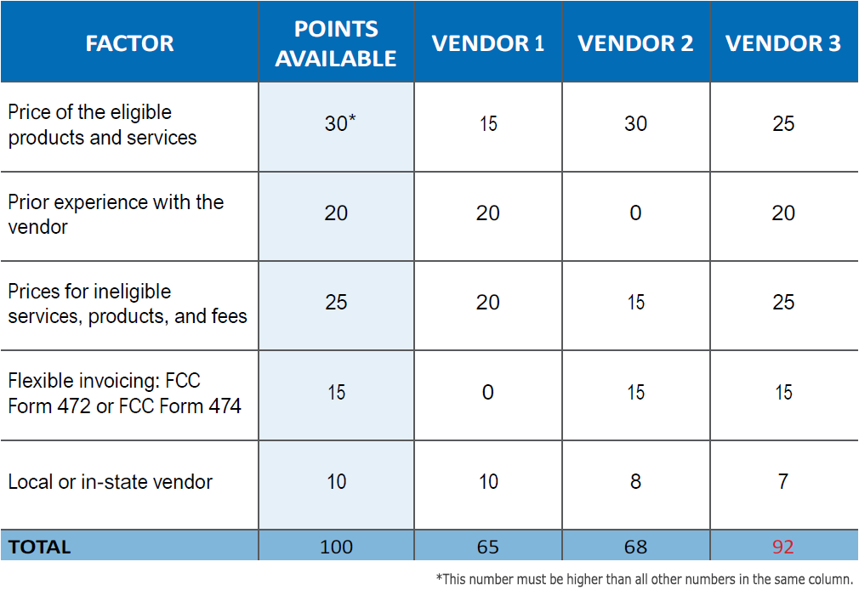
North Carolina E-rate
SAMPLE Form 470/RFP Timeline:

Event: | Day: | Date: | Time (Eastern):
File 470/Issuance of RFP
Deadline for Responder’s Technical Questions
Deadline for Requestor’s Responses (Post Answers)
Deadline for Bid/Proposal Submission
Public Opening of Bids
Evaluation of Proposals/Selection of Finalists
Contract Award (Board of Education Action Item if required)
Vendor Notification
Protest Deadline
Sign Contracts (Deadline)
File 471 (based on your 470)

